Summary of Perry Mansion Applications
1. CORRECTION ORDINANCE TO TRACTS 1-2 – Case No. C14-2014-0064 (Note: Zoning Ordinance No. 20140130-35 was approved on January 30, 2014)
Two items were erroneously contained in the ordinance approved 1-30-14 that require correction:
*Residential Only Setback (Part 3, Tract 1, Item B): the measurement of the residential use only setback has an incorrect measurement from Red River, and an incorrect configuration along the north property line. The former error results in the setback skewing towards Red River instead of a straight north/south line aligned with adjacent residences, the latter error does not account for commercial uses for the Carriage House. The ordinance language should be revised to reflect the correct setbacks along Red River and the north property line as follows: “Only residential uses are permitted within 75 feet of the north zoning boundary line except for (i) the eastern portion most 150 feet, as measured from the property line adjacent to Red River, and (ii) the specified area along the north property line, all as shown on Exhibit ____.”
Additionally, an exhibit depicting the correct measurement and boundary of the setbacks from Red River and the north property line on Tract 1 will be attached to the correction zoning ordinance similar to the exhibit attached to the recorded private restrictive covenant (see Correction Zoning Application to Tract 1-2 Exhibit A attached). Note that Section 1.1.C.3.e of the private restrictive covenant specifically authorized non-residential uses for the Carriage House (“restaurant location may include the Carriage House and LaBelle Hall”). For comparison, see Exhibit B attached showing the incorrect Tract 1 setbacks based on the zoning ordinance approved on January 30, 2014.
* Access to Red River (Part 3, Tract 2, Item A): this section should be deleted as access to Red River from Tract 2 should be allowed: “Vehicular access from Tract 2 to Red River is prohibited, except for pedestrian, bicycle and emergency ingress and egress. All vehicular access to Tract 2 shall be from other adjacent public streets or through other adjacent property.” Access to Red River from Tract 2 has always been contemplated in connection with development of the Perry Estate and, for example, was specifically referenced in the private restrictive covenant in Section 1.1.D.3 (“Service vehicles for hotel uses will enter/exit exclusively on Red River”).
Status: Zoning Application filed with the City on April 23, 2014.
Timeline: Planning Commission and City Council (tentatively May-June 2014)

2. TRACT 3 REZONING - 3.325 acres – Case No. C14-2014-0063
The most westerly portion of the remaining Perry Mansion site is currently zoned SF-3. The zoning ordinance approved January 30, 2014, only covered Tracts 1-2. However, the private restrictive covenant covered Tract 3 and restricted it to a maximum of 9 residential units and also contained building massing and design restrictions for those units (Exhibit C attached). The rezoning request for SF-6-CO-NP covers only Tract 3 and authorizes construction of 9 condominium units. (Exhibit D attached). Rezoning to SF-6-CO-NP offers substantial advantages for developing 9 residential units on Tract 3, as compared to existing zoning. For example, SF-6-CO-NP authorizes development of the 9 residential units as condominiums, which offers flexibility for design that is more sensitive to adjacent residences, including clustering the condominium units. In contrast, developing single family residential structures under existing SF-3 zoning standards mandates individual lot layouts that take up a larger area with buildings allowed closer to the adjacent neighbors. The existing SF-3 zoning authorizes more intensive uses located closer to adjacent residents such as a church and school with lighted sport courts/ballfields.
Status: Zoning Application filed with the City on April 23, 2014
Timeline: HNA (tentatively May); Planning Commission and Council (tentatively June-Aug)
3. TRACT 3 NEIGHBORHOOD PLAN AMENDMENT (NPA) – 3.325 acres Case No. NPA-2014-0019.01
This is the companion application to the rezoning of Tract 3. The current land use on the Future Land Use Map (FLUM) is Civic and this application seeks to change the FLUM to Higher Density Single Family Residential, which will match the SF-6 zoning request area pertaining only to Tract 3. (Exhibit D attached).
Status: FLUM Application filed with the City on February 27, 2014
Timeline: City Community Meeting (tentatively May); CANPAC (tentatively June); Planning Commission and Council (tentatively June-Aug)
4. DEMOLITION APPLICATION – CONVENT BUILDING Case Nos. PR-2014-040754 and HDP-2014-0327
This request is for demolition of the Convent Building, which is the closest building to Red River. The Convent Building was constructed around 1948 and is not part of the original Perry Mansion structures or integral to the historic character of the property that was established from 1917-1944. (Exhibit E attached)

Status: Demolition Application was filed with the City on April 21, 2014
Timeline: Historic Landmark Commission hearing – May 19, 2014

5. DEMOLITION APPLICATION –CLASSROOM/GRIFFIN BUILDING Case Nos. PR-2014-040723 and HDP-2014-0326
This request is for demolition of a portion of the Classroom Building, which is located northwest of the Perry Mansion building. The Classroom Building was constructed around 1948 and is not part of the original Perry Mansion structures or integral to the historic character of the property that was established from 1917-1944. (Exhibit F attached)
Status: Demolition Application was filed with the City on April 21, 2014
Timeline: Historic Landmark Commission hearing – May 19, 2014

6. CONDITIONAL USE SITE PLAN (CUP) - currently not on file
This request will be for a CUP to allow for an Outdoor Entertainment use. As contemplated with zoning ordinance for Tracts 1-2 adopted January 30, 2014, and the private restrictive covenant, an Outdoor Entertainment use was contemplated for the Perry Mansion building and surrounding sunken gardens in the southeast portion of the site (Tracts 1 and 1A). Outdoor Entertainment is a conditional use per GR zoning and therefore a CUP is required for this use. The CUP will incorporate all relevant restrictions from the private restrictive covenant and will only cover portions of Tracts 1 and 1A. (Exhibit G attached).

7. OVERALL SITE PLAN – currently not on file
This request will be for construction of the overall site. This site plan will include all proposed buildings and parking, etc. on Tracts 1-3.
Exhibit List:
EXHIBIT A – Correction Zoning Application to Tract 1 and 2
EXHIBIT B – Incorrect Setbacks Tract 1 Per Zoning Ordinance Approved 1-30-2014
EXHIBIT C -- Section 1.1E of the Recorded Private Restrictive Covenant
EXHIBIT D – Tract 3 Zoning and FLUM Area Exhibit
EXHIBIT E – Convent Building
EXHIBIT F – Classroom Building

EXHIBIT A – Correction Zoning Application to Tract 1 and 2
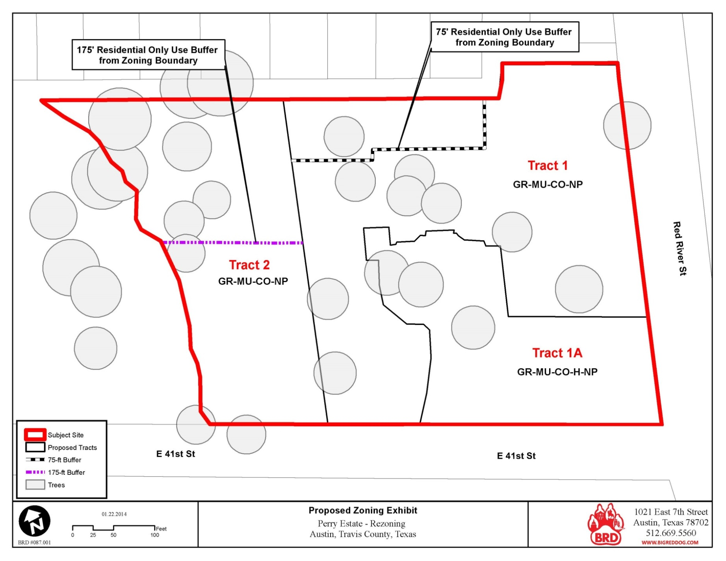
EXHIBIT B – Incorrect Setbacks Tract 1 Per Ordinance Approved 1-30-14
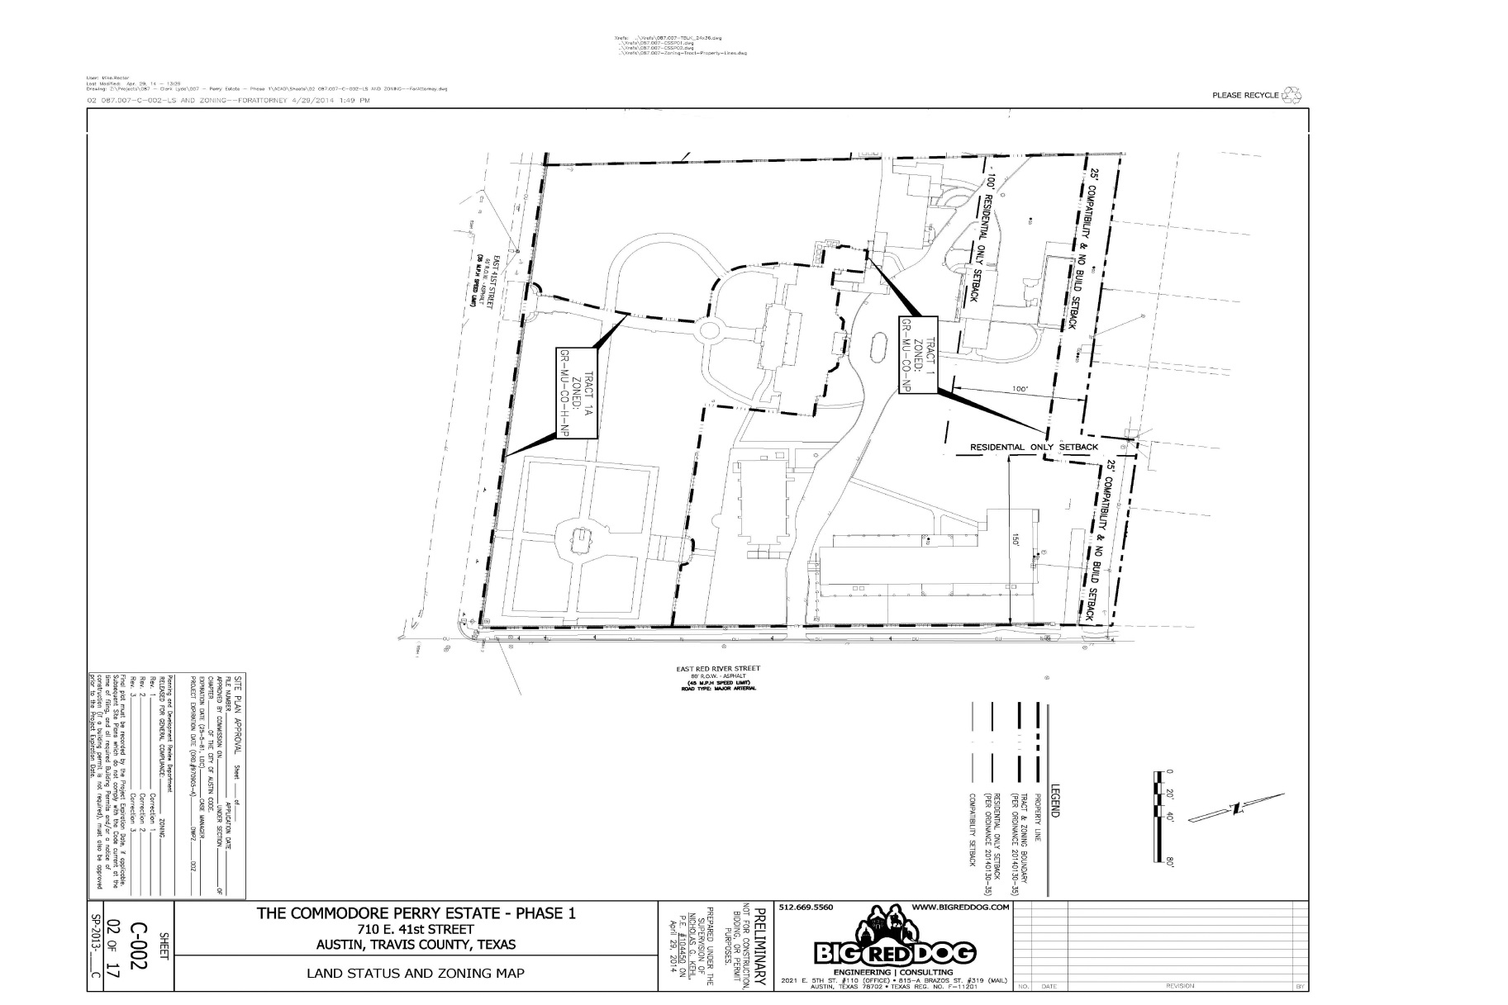
EXHIBIT C
Section 1.1E of the Recorded Private Restrictive Covenant

- Restrictive Covenants Applicable Only to Tract 3
- Height, number/size, uses.
  - Maximum number of residential units on Tract 3 shall be nine (9).
  - No residential units may share a common wall.
  - Massing of residential buildings along western property line:
    - Buildings shall be maximum of 2 stories, and shall not exceed 30 feet high from finished grade, measured in accordance with Land Development Code Subchapter F, Sections 3.4 through 3.5 as in effect January 2014 (see attached Exhibit “G”).
    - Buildings shall maintain single-family massing and scale along west property line comparable to adjacent residences and surrounding neighborhood.
    - Buildings shall maintain multiple sight lines from west property line to the east; and shall avoid use of continuous or unbroken wall plane along westernmost building faces.
    - First tier of buildings along west property line must be not more than fifty feet (50’) wide, as measured along the side of the buildings that are most parallel to the western property line.
    - Buildings along west property line must be at least ten feet (10’) apart from another building, as measured from wall face to wall face, and shall face easterly.
  - All commercial uses that are permitted or conditional uses pursuant to Section 25-2-491 of the Land Development Code Zoning Use Summary Table as in effect January 2014 are prohibited.

EXHIBIT D – Tract 3 Rezoning and FLUM Area Exhibit
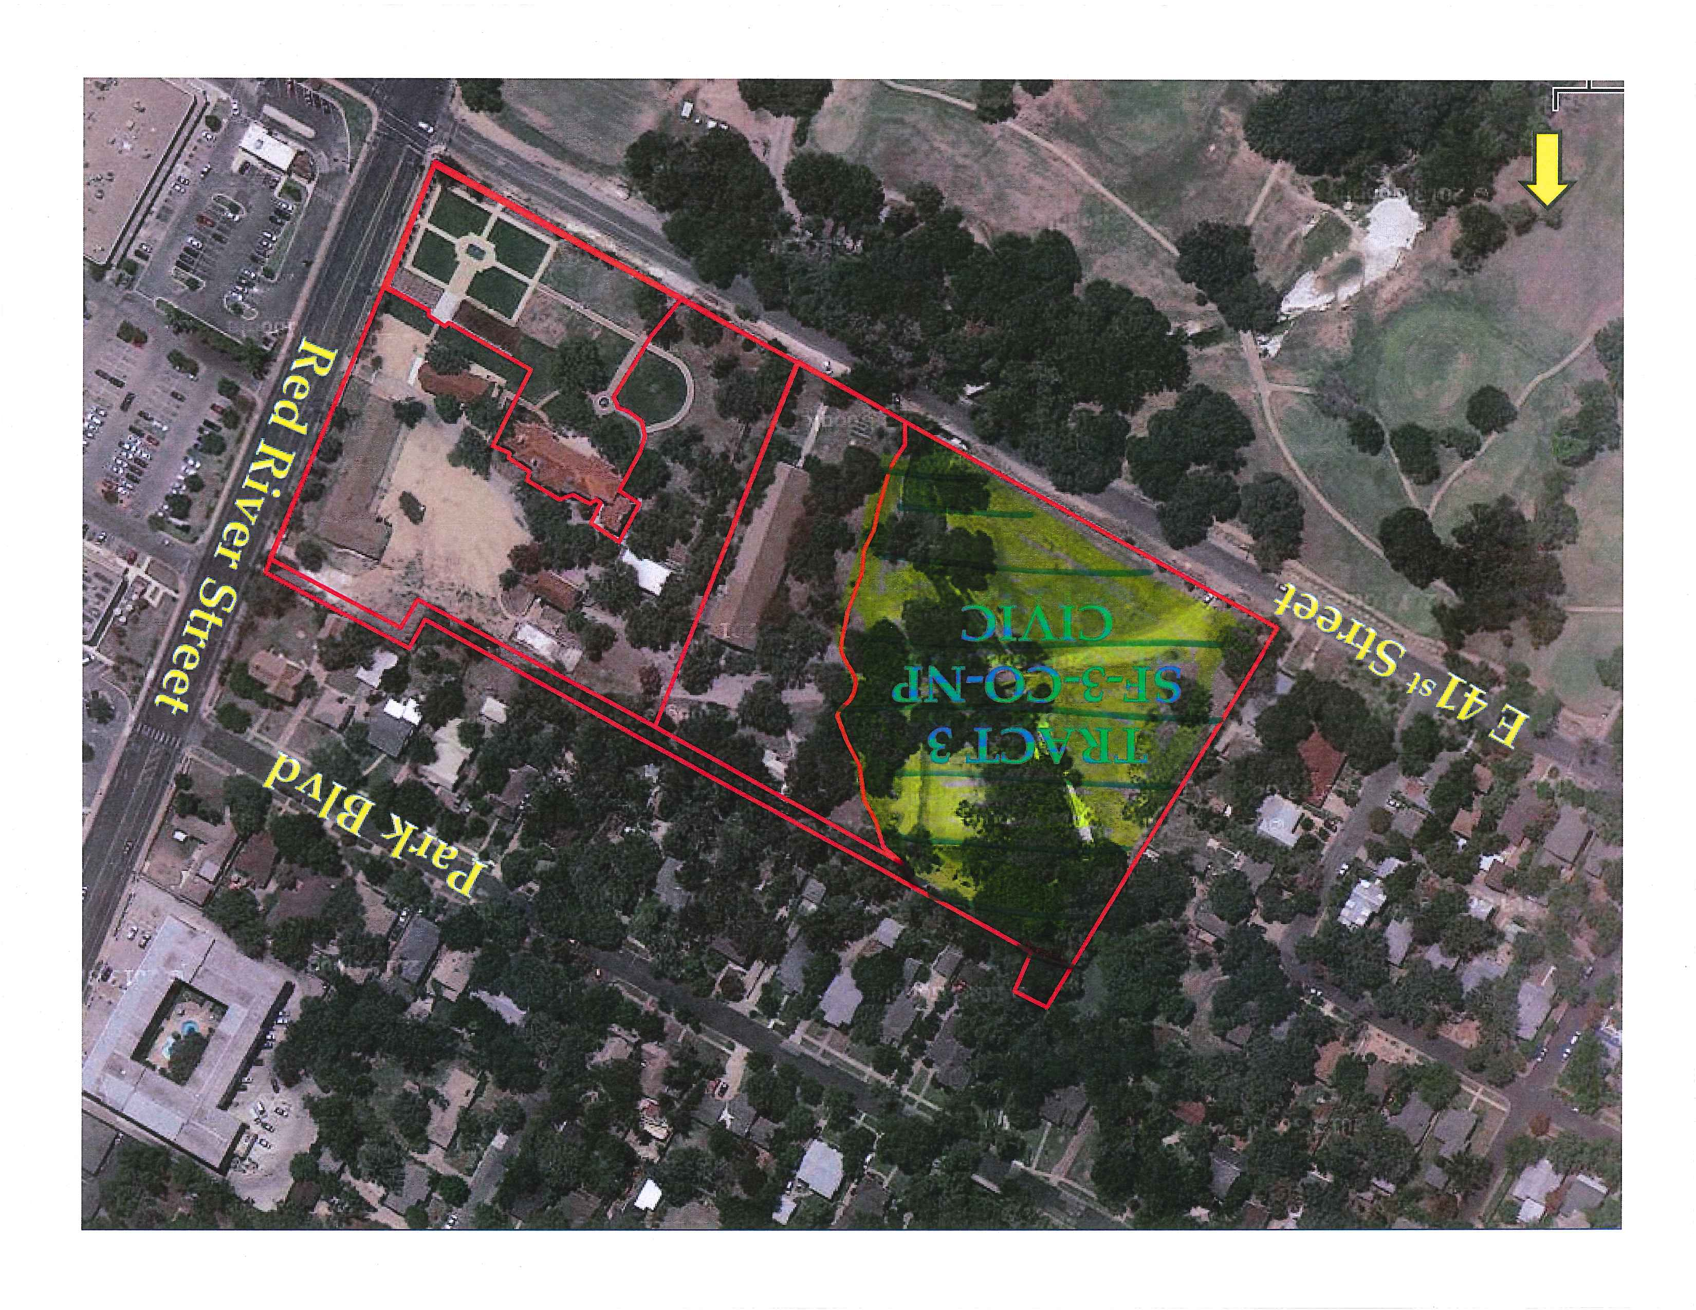
EXHIBIT E – Convent Building
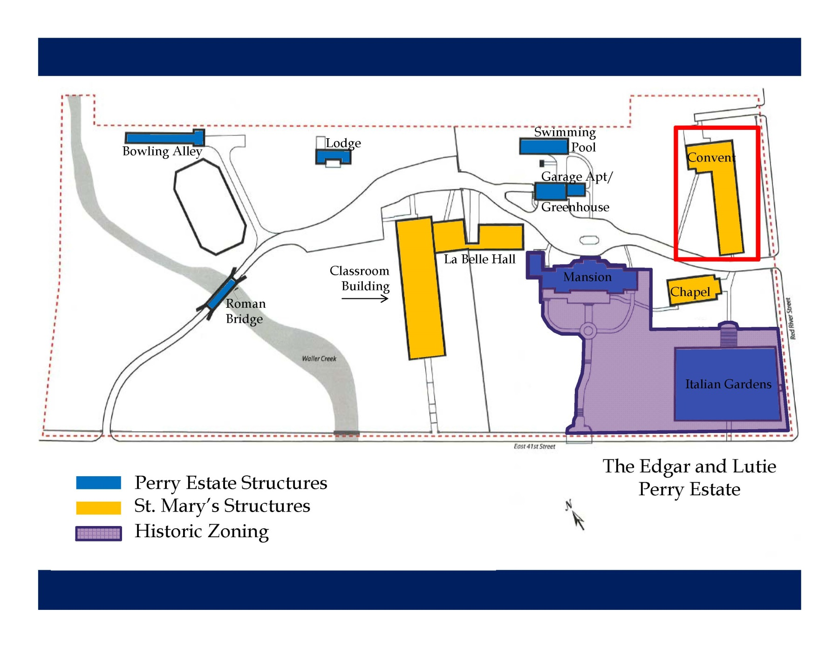

EXHIBIT F – Classroom Building
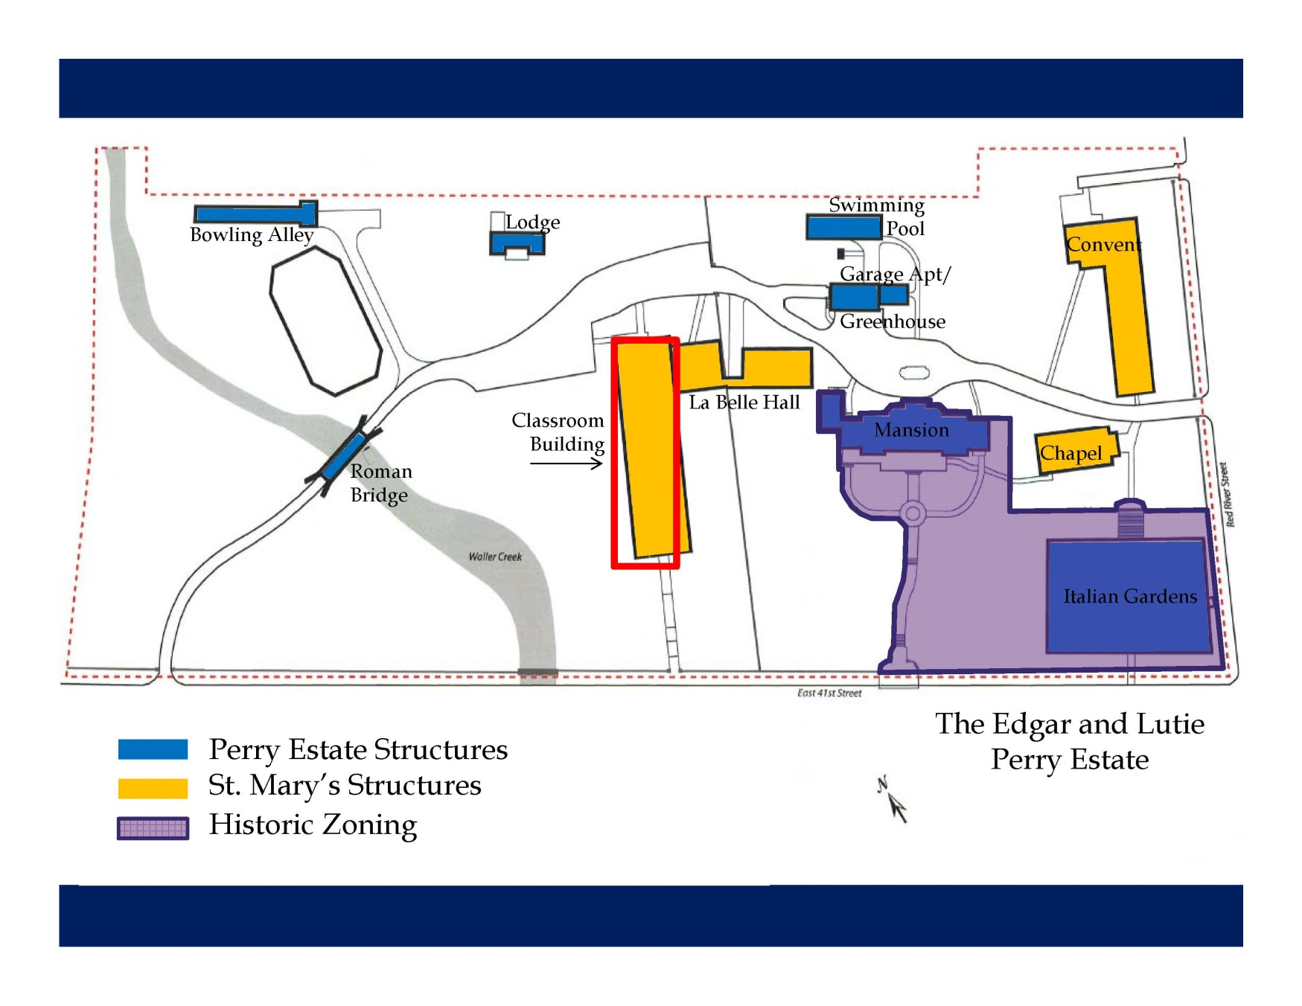

EXHIBIT G – Conditional Use Permit
