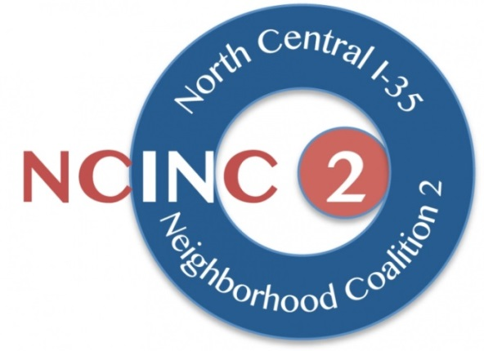

North Central I-35 Neighborhood Coalition 2
AGENDA for August Regular Meeting
Fannie Mae Stewart Community Conservatory
1902 East 22nd Street

22 August 2015

2:00 Call to Order; Secretary to call a quorum
2:00 – 2:05 Introductions & Announcements
- Pedestrian Advisory Council Applications due September 18
2:05 – 2:10 Approval of minutes from July 18 meeting
2:10 – 2:20 Neighborhood Updates

2:20 – 3:00 Discussion of Proposed Resolution Regarding Upper Decks Proposal
3:00 – 3:20 Discussion of outreach to Council Members and Mayor
3:20 – 3:30 New business

3:30 Adjourn

